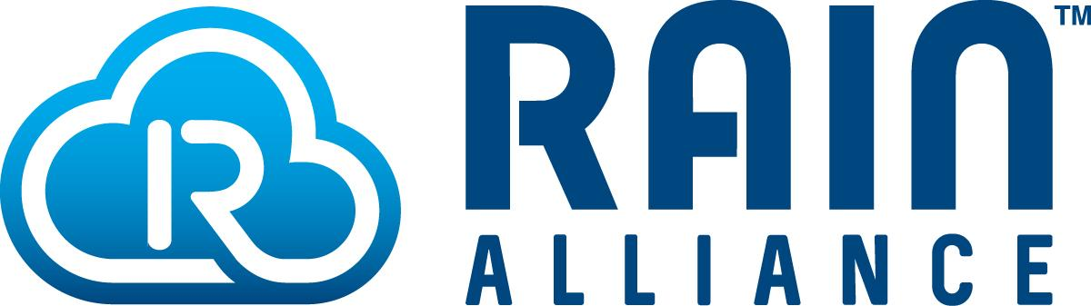
RAIN RFID Brand Guide
Marketing Document
V.3
February 2022

Why Use the RAIN RFID Brand
Today, people use terms including RFID, UHF RFID, passive RFID, passive UHF RFID, EPC RFID, etc. interchangeably to mean the same thing. This has caused confusion in the industry. RAIN RFID is the brand name chosen by the industry to represent products that are compatible with the open, global GS1 UHF Gen2v2 specification and ISO 18000-63 standard.
As the fastest-growing segment of the RFID market, with billions of tag ICs sold to date, RAIN RFID is used in many markets and industries worldwide to identify, locate, authenticate, and engage items--providing numerous benefits to end users. While other IoT technologies bring other capabilities and values, none can match RAIN RFID for cost, simplicity, and availability.
The RAIN RFID name and logos allow a business, its products, solutions, and capabilities to associate with this rapidly growing market. The RAIN RFID brand provides a clear identifier that helps people both clarify and differentiate from other IoT and RFID technologies. It reduces confusion and provides a mechanism for creating industry awareness of, and education about, the core capabilities and value of the technology so businesses can focus on selling.

About the RAIN RFID Brand Usage Guide
The purpose of this document is to detail the proper industry use of the technology product identifier “RAIN RFID” in content and imagery. This includes establishing its correct usage in documents and online. The guide also includes standard RAIN RFID definitions, descriptors and logos that can be used by anyone.
RAIN RFID should be used and/or replace all relevant references to RFID, UHF RFID, passive RFID, passive UHF RFID, EPC RFID in an organization’s technical, sales and marketing materials. The proper use of RAIN RFID in this way will improve market clarity and end-user understanding of the technology and its benefits. Much like the term “Wi-Fi” has simplified the way we talk about technology used for unplugged internet access, and the term “Bluetooth” has simplified the way we talk about exchanging data with a mobile device, the term RAIN RFID simplifies the way we talk about enabling visibility into the trillions of unpowered things in our world.

RAIN RFID Brand Usage
WHY USE RAIN RFID: RAIN RFID is the brand name chosen by the industry to represent products that are compatible with the open, global GS1 UHF Gen2v2 protocol and ISO 18000-63 standard. Using consistent terminology – RAIN RFID - eliminates confusion and clarifies for the end-user the technology’s capabilities and applications. It acts as a “short cut” for people to understand what is being discussed.
WHEN TO USE RAIN RFID: Use RAIN RFID in place of other phrases like RFID, UHF RFID, passive RFID, passive UHF RFID, EPC RFID. The RAIN name should be coupled with RFID to create the phrase “RAIN RFID” at first mention. For subsequent references in a document or online, or by itself “RAIN” can be used by itself.

Examples
INCORRECT USE: The Acme product is fully compliant with the GS1 EPC/RFID Gen2v2 standard and supports RAIN RFID.
CORRECT USE: The Acme RAIN RFID product is fully compliant with the GS1 UHF Gen2v2 protocol.
INCORRECT USE: Our products are RAIN RFID-compliant.
CORRECT USE: Our RAIN RFID products comply with the GS1 UHF Gen2 protocol.
INCORRECT USE: Our products are RAIN RFID approved and meet global industry standards and regulations.
CORRECT USE: Our RAIN RFID products meet global industry standards and regulations.
INCORRECT USE: RAIN RFID is a global alliance promoting the universal adoption of UHF RFID technology.
CORRECT USE: The RAIN Alliance is a global alliance promoting the universal adoption of RAIN RFID technology.
INCORRECT USE: RAIN RFID uses the GS1 UHF Gen2 protocol which ISO/IEC has standardized as 18000-63.
CORRECT USE: RAIN RFID is a wireless technology based on the UHF RFID protocol standard developed by GS1 and ISO. Its benefits include superior read range and fast data transfer.

WHERE: Use RAIN RFID in content such as: advertisements, blogs, case studies, data sheets, ebooks, emails, infographic, podcasts, presentations, press release, report, social media, solution brief, video, white paper, etc. Standard language describing RAIN RFID technology is below and available for your use. The term “RAIN RFID” can be used to identify a variety of things, including:
- RAIN RFID tags
- RAIN RFID readers
- RAIN RFID solutions
- RAIN RFID applications
- RAIN RFID technology

HOW: The language we use is important. To be effective it must be straightforward and truthful. Use of RAIN RFID or RAIN must be constant throughout a document. In short, RAIN RFID language and content should be:
- Clear: Message and copy are concise and coherent using simple words and short sentences.
- Appropriate: RAIN RFID must be used in the content. Content must address appropriate topics and audiences.
- Useful: Content has a clear goal and targets specific audience(s).
- Truthful: Claims are validated with data and research.
Voice: “Voice” is the tone delivered by written or online content. For RAIN RFID the voice should be:
- Upbeat: Tone is positive and cordial, inspiring truth, innovation and efficiency.
- Innovative: RAIN RFID is an innovative, exciting technology. RAIN RFID content should convey this fact.
- Credible: The truth about RAIN RFID and what it can do – and will do – should be communicated simply and plainly to build and enhance credibility.
In sum, the language and tone of voice used for RAIN RFID material should be positive, straightforward and truthful.

RAIN RFID Definition
For use when describing RAIN RFID. This definition can be used in its entirety. Simply copy and paste the following into whatever document you are working on.
RAIN RFID is a name or identifier for passive UHF radio-frequency identification products (RFID) and technology that comply with the ISO/IEC 18000-63 standard and/or the GS1 EPC UHF Gen2 protocol.

RAIN RFID Descriptor
For use when a longer definition or more background about RAIN RFID is needed. This descriptor can be used in its entirety. Simply copy and paste the descriptor into whatever document you are working on.
RAIN RFID is one of the most pervasive technologies in the world and is used in many markets for efficient identification, localization, and authentication of products.
While other IoT technologies bring other values, none can match RAIN RFID for cost, simplicity, and availability. So, it's no surprise that the RAIN RFID market is the fastest-growing segment with tens of billions of tags sold.
The RAIN brand name represents passive ultra-high frequency (UHF) RFID technology based on the GS1 EPC UHF Gen2 protocol and ISO/IEC 18000-63 standard. The brand provides a clear and simple identifier for the wide variety of products and services that comply with the standard. For more information, visit: rainrfid.org

“About” RAIN RFID Paragraph
For use when an “About” paragraph or background information on the RAIN RFID brand is needed. This “About” paragraph can be used in its entirety. Simply copy and paste the paragraph into whatever document you are working on.
RAIN RFID is the industry brand name for passive UHF radio-frequency identification products and technology that comply with the ISO/IEC 18000-63 standard and GS1 EPC UHF Gen2 protocol, the fastest growing type of RFID available today. The RAIN RFID brand was established in 2014 by the RAIN Alliance and is now in use around the world.
RAIN Alliance Definition
For use when a description of the RAIN Alliance is required. This definition can be used in its entirety. Simply copy and paste into whatever document you are working on.
The RAIN Alliance is the industry organization supporting the universal adoption of RAIN RFID, a wireless technology that connects billions of everyday items to the Internet of Things, enabling businesses and consumers to identify, locate, authenticate, and engage assets. For more information or to join the non-profit organization, visit rainrfid.org.

RAIN RFID and RAIN Alliance Official Logos
The RAIN Alliance established the RAIN RFID brand and logos to help companies and end-users, commercial and consumer, identify the specific UHF RFID standard (ISO/IEC 18000-63 and GS1’s EPC “Gen2”) technology and products. The RAIN Alliance brand and logo were established for this organization to support RAIN RFID technology.

RAIN RFID Logos
These logos are available in different formats.
Vertical logos |  | Horizontal logos | Cloud logo
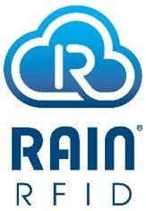 | 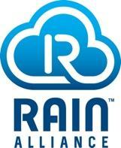 |  | 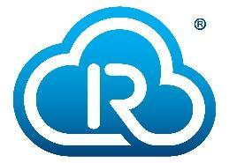

The RAIN Brand Guide is provided to help understand proper use of the RAIN RFID and RAIN logos to ensure global consistency.
Anyone can download and use the RAIN RFID logos on marketing materials and websites. The only limitation regarding how the RAIN RFID logos can be used is regarding RAIN RFID technology products. Only RAIN Alliance members can use the RAIN RFID logo on products, upon approval of an application request. To request permission to use the RAIN logo on products, contact the RAIN Alliance.
You should always use the vertical or horizontal logo if there is space available. The cloud logo can only be used when there is not enough space for the complete RAIN RFID logo.

Common RAIN RFID Logos
Download Horizontal RAIN RFID Logo for Web
Download Horizontal RAIN RFID Logo for Print
Download Vertical RAIN RFID Logo Here for Web
Download Vertical RAIN RFID Logo for Print
Download Cloud RAIN RFID Logo for Web
Download Cloud RAIN RFID Logo for Print

RAIN Alliance Logos
Download Horizontal RAIN Alliance Logo
Download Vertical RAIN Alliance Logo

Logo Size Guidelines
The RAIN RFID or RAIN Alliance logos should be sized appropriately for the material on which it appears. An appropriate logo size is one that maintains the logo’s ratio and provides an appropriate amount of white space around the logo, as represented by “x” in the images below.
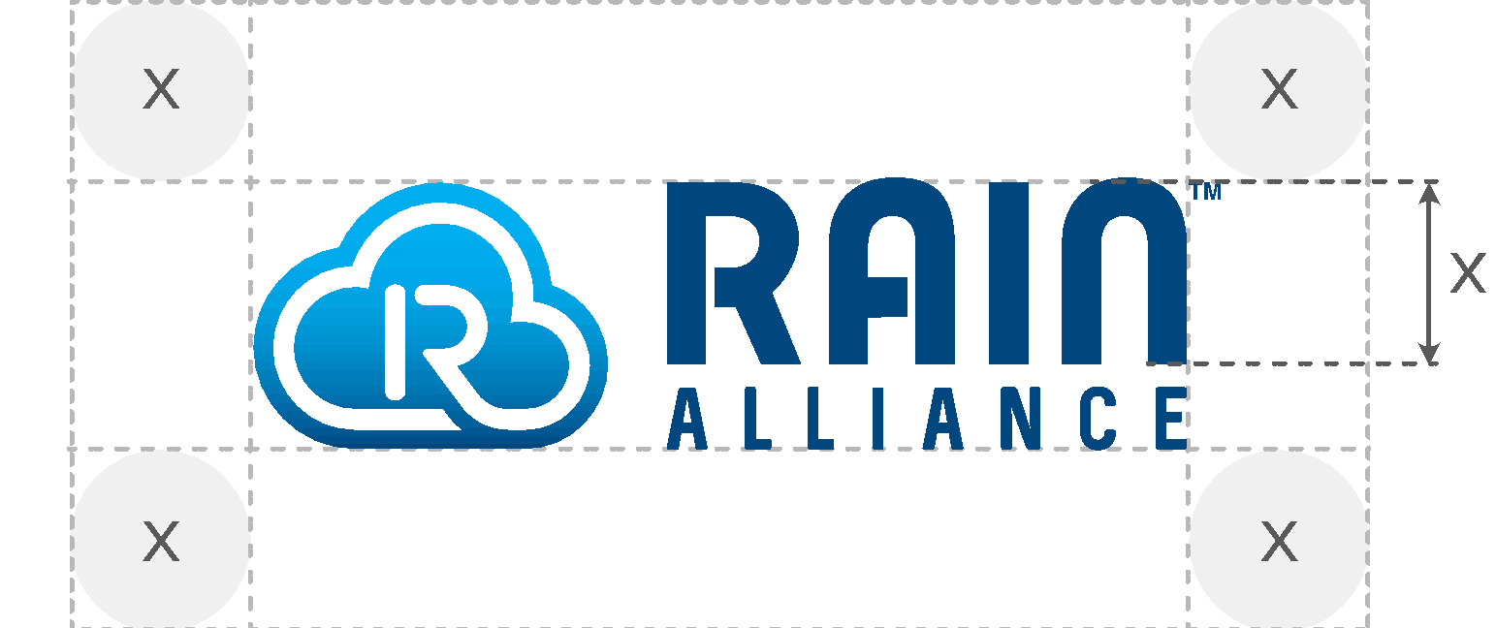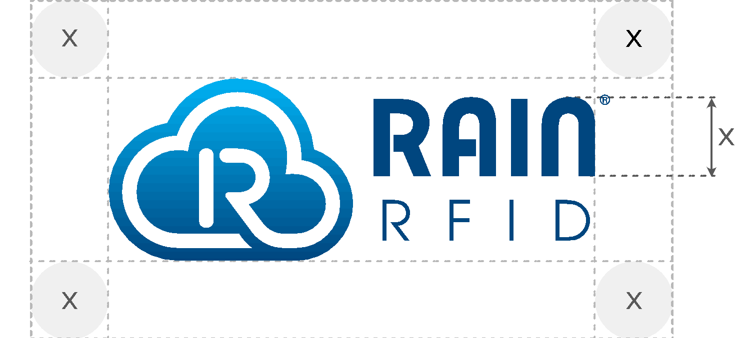
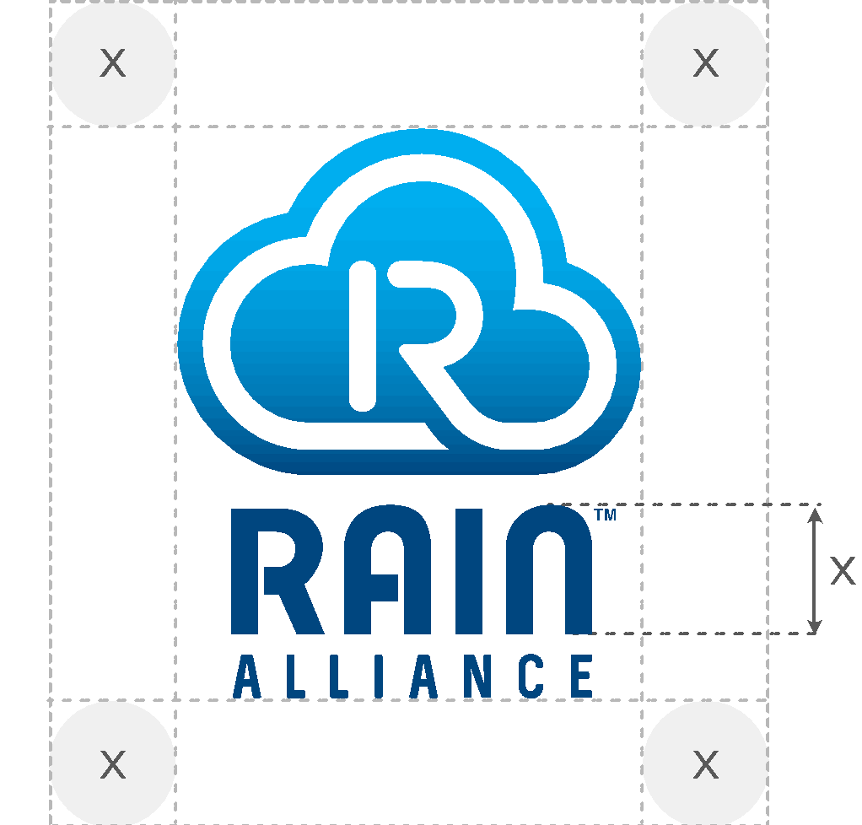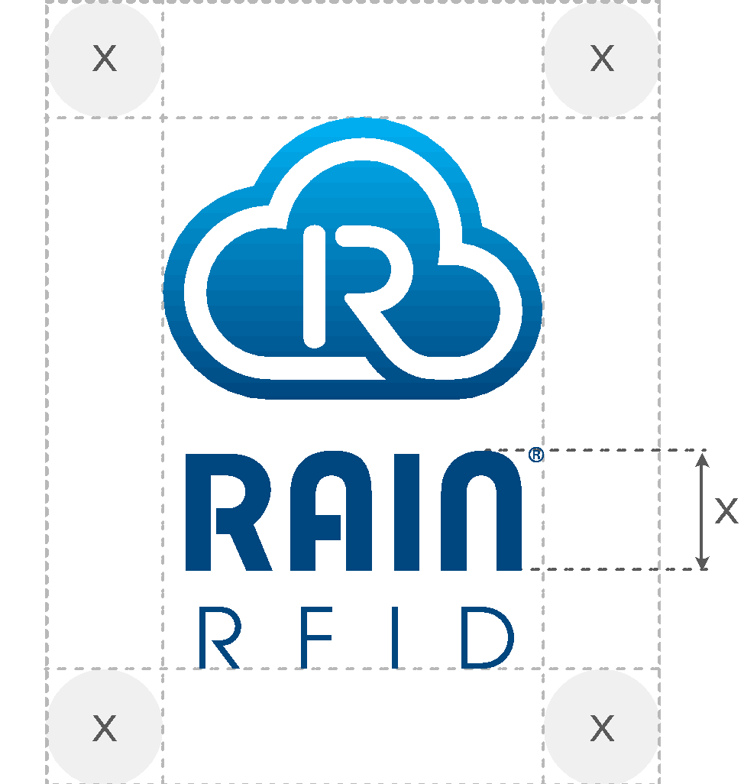

Logo Ratios
The ratio should be maintained in all sizes of the logo. Do not stretch or distort the logo in any way.
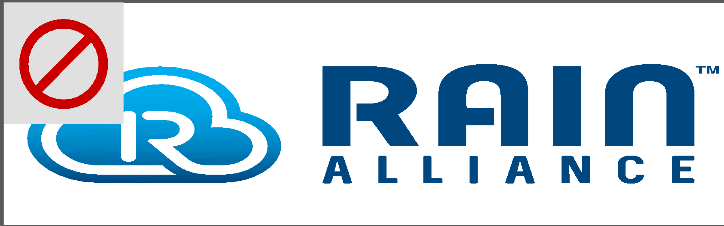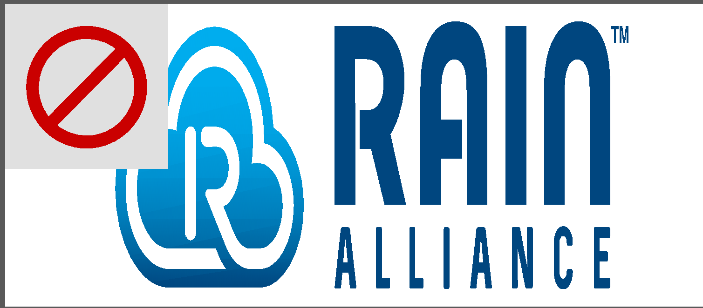

White Space Around the Logo
The logo should include white space around the logo. The logo should never “touch” another logo or text element.
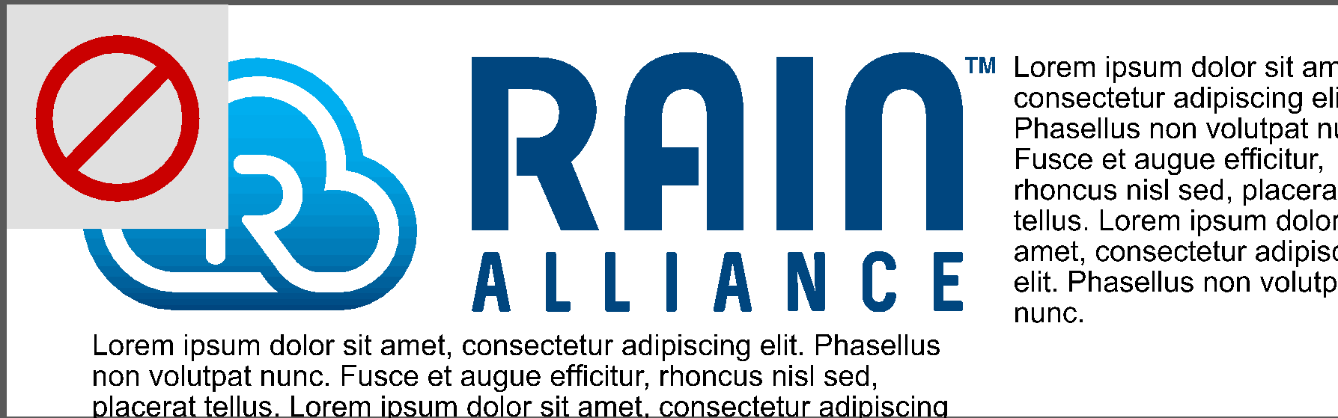

Horizontal alignment
When horizontally aligning either the RAIN or the cloud logo with other corporate logos (as in a sponsorship block), make sure the base of the RAIN logo or cloud logo aligns with the base of the other logos.

Vertical alignment
When vertically aligning the RAIN logo or cloud logo with other corporate logos (as in a list of sponsors), either center the logos or align the RAIN RFID logo’s cloud with the left edge of the other logos. Do not float the cloud in the RAIN logo outside of the margin.
Contact the RAIN Alliance if you have any questions – info@rainrfid.org.
RAIN RFID Brand FAQs
- What does it mean when you say “RAIN” is the brand name for passive UHF RFID?
RAIN RFID is a name or identifier for passive UHF radio-frequency identification (RFID) products and technology that comply with the ISO/IEC 18000-63 standard and/or the GS1 EPC UHF Gen2 protocol. Branding a technology with a name is done to provide a common and recognizable identity, establish consumer and business awareness as well as to foster brand loyalty to support a sales process. Much like the term “Wi-Fi” has simplified the way we talk about technology used for unplugged internet access, and the term “Bluetooth” has simplified the way we talk about exchanging data with a mobile device, the term RAIN simplifies the way we talk about enabling visibility into the billions of unpowered assets that make up the bulk of our world.
- Why does RFID need a brand name?
There are many different types of RFID technology. The differences include frequencies (UHF, HF, LF), standards, and intended uses. The RAIN brand name distinguishes the GS1 EPC UHF Gen2 protocol and ISO/IEC 18000-63 standard, which use a specific passive ultra-high frequency (UHF) RFID technology from other forms of RFID. It provides a clear and simple identifier for the wide variety of products and services that comply with the standard. The RAIN RFID brand simplifies the terminology and makes it easier for the end-user to understand the uses and value of the technology. Similarly, the NFC brand provides differentiation for the Ecma-340, ISO/IEC 18092 standard which uses a specific version of passive HF RFID.

- How does using the RAIN RFID brand name and logo benefit me?
As the fastest-growing segment of the RFID market with over 80 billion tag ICs sold to date, RAIN RFID is used in many markets and industries worldwide to identify, locate, authenticate, and engage items--providing numerous benefits to end users. While other IoT technologies bring other values, none can match RAIN RFID for cost, simplicity, and availability. The RAIN RFID name and logos associate your business and products to this rapidly growing market. The RAIN RFID brand provides a clear identifier that helps people both clarify and differentiate passive UHF technology, for use on any value chain, from other IoT and RFID technologies. It reduces confusion and provides a mechanism for creating industry awareness of, and education about, the core capabilities and value of the technology so businesses can focus on differentiating products and services from competitors. Some of the uses of RAIN RFID include traceability in healthcare, smart manufacturing, and supply chain efficiency, to name just a few.
- Who can use the RAIN RFID brand name and logo?
The RAIN RFID name and logo may be used by anyone (RAIN Alliance members and nonmembers) on marketing materials. The only limitation regarding how the RAIN RFID logos can be used is when used on products. Only RAIN Alliance members, who have submitted an application and received approval, can use the RAIN RFID logo on RAIN RFID products. For more information: visit the RAIN member forum.
- How did you come up with RAIN RFID as a brand name?
The RAIN RFID brand name was adopted in 2014 when several companies working with passive UHF RFID technology began to see that the term “RFID” was being used very broadly – to represent multiple types of sensor technologies – many of which did not have the same cost-effective, transformational capabilities of passive UHF RFID. This created a concern that the expanding use and meaning of the term “RFID” might confuse the market. At the same time, these companies saw the growing importance of the technology in enabling the Internet of Things. The word RAIN—an acronym derived from RAdio frequency IdentificatioN—is intended as a nod to the link between UHF RFID and the cloud, where RFID-based data can be stored, managed and shared via the Internet.
- What is the RAIN Alliance?
The RAIN Alliance is the industry organization supporting the universal adoption of RAIN RFID, a wireless technology that connects billions of everyday items to the Internet of Things, enabling businesses and consumers to identify, locate, authenticate, and engage assets.
- Where can I get more information on the use of RAIN RFID?
The RAIN Alliance website includes industry news, ebooks, whitepapers, customer stories and more: www.rainrfid.org.
- When should I use the RAIN RFID brand?
When speaking to partners, customers, coworkers, media, investors, and more, using the RAIN RFID term at least once in conversation will help eliminate confusion and share the value of the technology. We recommend you use the term RAIN RFID instead of, or in addition to, RFID or passive UHF RFID. The more you use it, the more awareness it will create, improving communications between you and the customer. It can also simplify marketing and sales efforts.
- What makes RAIN RFID different from other forms of RFID?
RAIN RFID identifies, locates, authenticates and engages items using passive Ultra-High Frequency (UHF) RFID (Radio Frequency Identification) technology that complies with the GS1 EPC UHF Gen2 protocol and the ISO/IEC 18000-63 standard. RAIN RFID tags cost pennies, don't require batteries to communicate, can be read, or interrogated, at short or long range (up to 10 meters), without line-of-sight (through most materials such as cartons, boxes, wood, etc.), at high speeds and volumes (more than 1,000 tags per second). These unique capabilities make it ideally suited for use on trillions of items from apparel to pharmaceuticals to food, all along the supply chain.
In comparison, Low-Frequency (LF) RFID only provides short range (centimeters) and reads one tag at a time. High frequency (HF) RFID is commonly used for access control mobile payment or inside your passport, public transport ticket. The NFC brand refers to a particular type of HF RFID. Active RFID uses batteries to communicate, increasing the read distance to several tens of meters. For more information download the “What is RAIN RFID Ebook”.
- How do I tell the RAIN RFID story? Is there already existing material available?
The RAIN Alliance Brand Usage Guide includes sample copy that can be used by anyone. And the RAIN Alliance website includes industry news, ebooks, whitepapers, customer stories and more: www.rainrfid.org.
- What should I do to promote RAIN RFID to my customers?
You can create RAIN RFID marketing materials, share both internally and externally, and update your website. If a customer is unfamiliar with RAIN RFID, share information and evangelize. These educational materials provide you with a great reason to contact a customer. RAIN Alliance resources can be found here.

ABOUT RAIN ALLIANCE
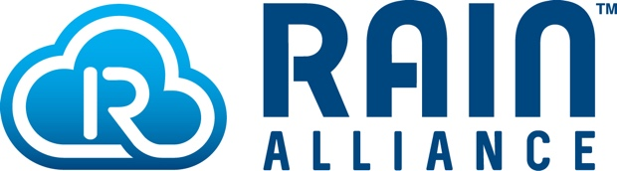
The RAIN Alliance is an organization supporting the universal adoption of RAIN RFID technology. A wireless technology that connects billions of everyday items to the internet, enabling businesses and consumers to identify, locate, authenticate and engage each item. The technology is based on the EPC Gen2 UHF RFID specification, incorporated into the ISO/IEC 18000-63 standard. For more information, visit www.rainrfid.org.

RAIN Alliance
401 Edgewater Place, Suite 600 Wakefield, MA, 01880, USA

Visit the RAIN RFID website – RAINRFID.org. If you are interested in learning more about the RAIN RFID Alliance, contact us at info@rainrfid.org.

