RAIN Company Identification Number (CIN) directive

Date: 2022-08-15
Version: 1.0

History of modifications

Version | Date | Author | Description
0.1 | 2021-03-23 | Steve Halliday | Document creation
0.2 | 2021-04-29 | Bertus Pretorius | Updated
0.3 | 2021-05-14 | SGH, AJP, MMB & JJS | Collated comments and updates
0.4 | 2021-06-17 | MMB | Update suggestions from MMB
0.5 | 2021-06-30 | BP and team | Ensure terminology and process to be accurate to the latest decisions.
0.6 | 2022-06-08 | SGH and team | Updated to better reflect process
1.0 | 2022-08-15 | SGH and team | Fix several editing issues.  Added the Text formatted CIN.  Clarify the classes

Table of Contents
History of modifications 1
1 Introduction 3
2 The RAIN CIN 3
2.1 Specification and rules 3
2.2 RAIN Number encoding of the RAIN CIN 4
2.3 Standards use of the RAIN CIN 5
3 RAIN CIN assignment 5
3.1 Rules 5
3.2 CIN classes 6
3.3 Experimental RAIN CINs 6
4 RAIN CIN registration 6
4.1 General 6
4.2 Process 7
4.3 Request information 8
4.4 Response information 8
4.5 Appeal resolution 8
4.6 The RAIN CIN committee 8
5 CIN maintenance 9
5.1 General 9
5.2 CIN status 9
6 Rules and obligations 9
6.1 General 9
6.2 Agency (RAIN Alliance) 10
6.3 Entity 10
6.4 The RAIN CIN committee 10
7 Reporting 11

Introduction
This document provides the rules, obligations, format and encoding of the RAIN Alliance Inc. Company Identification Number (RAIN CIN), allowing
- the RAIN Alliance Inc., as a Company Identification Number (CIN) issuing agency, to meet all the responsibilities, as specified by ISO/IEC 15459, for issuing agencies, and
- the legal entity (Entity) assigned a RAIN CIN to ensure its RAIN CIN is valid and current.
The RAIN Alliance Inc. has been issued an issuing agency code (IAC) "XRA" in accordance with ISO/IEC 15459.
The RAIN Alliance shall issue unique RAIN CINs to legal entities as a 1-to9-decimal number or a 1-to-4-text-string to be used with ISO specified barcode, NFC, and RAIN tag data standards. The RAIN Number tag data standard specifies a 1-to-4-byte encoding of the RAIN CIN. The first bit of each byte is used as a length indicator of the RAIN CIN encoding.
The RAIN CIN is an ISO/IEC 15459 identity identifier. It is interoperable with all ISO Automated Identification Data Standards which use ISO/IEC 15459 codes. The RAIN CIN shall only be used in accordance with such data standards.
The RAIN Alliance is registered in accordance with ISO/IEC 15961 a unique identifier for application specific data (AFI = AE_{h}) numbering, call the RAIN Alliance Number. This number requires the use of a RAIN CIN encoded as in clause 2.2.
It is critical for the long-range multi-read nature of RAIN RFID that all RAIN tag data be standards compliant to prevent tag data interference of non-compliant tag data with standard compliant tag data. The rapidly increasing use of RAIN RFID over many application verticals is increasing the risk of system failure of both properly deployed and operating systems and new systems alike.

The RAIN CIN

Specification and rules
The RAIN CIN is a
- 7-, 14-, 21- and 28-bit number
- representing a
  - RAIN decimal CIN: 1 to 9-digit decimal number (e.g. 123456) with no leading zeros, or
  - RAIN text CIN: an equivalent 1-, 2-, 3- and 4-character case-sensitive text number using the printable subset of the 7-bit US-ASCII character set (ISO/IEC 646:US) excluding the space-character (e.g. “Ra-1”).
NOTE 1: The text character set is the characters (in the character set order):
!”#$%&\’()*+,-./
0123456789
:;<=>?@
ABCDEFGHIJKLMNOPQRSTUVWXYZ
[\]^_`
abcdefghijklmnopqrstuvwxyz
{|}~
NOTE 2: A RAIN text CIN can always be expressed as a RAIN decimal CIN. However, many RAIN decimal CINs do not have an equivalent RAIN text CIN.
NOTE 3: The RAIN text CIN, when used with ISO tag data standards other than the RAIN Number is limited to the characters 0 to 9 and A to Z (only capitals) as specified by ISO/IEC 15459.
The RAIN CIN shall be unique within the scope of the RAIN Alliance IAC.

RAIN Number encoding of the RAIN CIN
The RAIN Number is an ISO/IEC 15961 registered tag data specification. A RAIN Number stored in Memory Bank 01 of a tag shall be identified by setting the Protocol Control (PC) word fields T (standard toggle) to 1 and the AFI (Application Family Identifier) to the hexadecimal value AE_{h}.
The RAIN Number encoding is
- a 1, 2, 3 or 4 8-bit byte encoding
- of the 7-, 14-, 21- or 28-bit RAIN CIN
- followed by the application specific data.
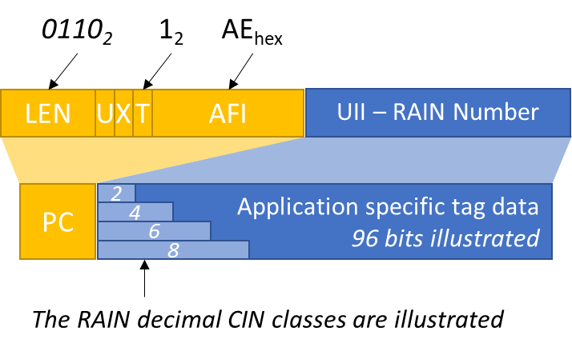
The encoding shall be as follow:
RAIN CIN | RAIN CIN bits | Byte encoding
7-bit | aaaaaaa | 0aaaaaaa
14-bit | aaaaaaabbbbbbb | 1aaaaaaa 0bbbbbbb
21-bit | aaaaaaabbbbbbbccccccc | 1aaaaaaa 1bbbbbbb 0ccccccc
28-bit | aaaaaaabbbbbbbcccccccddddddd | 1aaaaaaa 1bbbbbbb 1ccccccc 0ddddddd
- aaaaaaa shall be non-zero.
- The leading bit of the byte encoding has the follow meaning
  - 0: this is the last byte of the encoding, and
  - 1: the encoding has a byte following.
- aa…a, aa…b, aa…c and aa…d is a single number when using the decimal RAIN CIN representation/format.
- aa…a, bb…b, cc..c and dd…d is the 7-bit ASCII character encodings when using the text RAIN CIN representation/format.

Standards use of the RAIN CIN
AIDC standards like ISO/IEC 15434, ISO/IEC 15962, ISO/IEC 17360, and ISO/IEC 20248 may use the RAIN CIN with the IAC set to "XRA" and the AFI set to “AE_{h}” where appropriate. The following rules apply:
- The decimal number format:
  - Where the relevant specification has a length indicator: Leading zero shall not be used, i.e., the decimal number is used as assigned, e.g., 123456.
  - Where the relevant specification does not have a length indicator: The decimal number shall be prepended with leading zeros to 8 decimals, e.g., 00456789.
- The text format:
  - Special characters and lower case may not be used.
  - Where the standard specification has a length indicator: Space padding shall not be used, i.e., the text number shall be used as assigned, e.g., Ra-1.
  - Where the standard specification does not have a length indicator: The text string shall be padded at the end with the space-character to four characters, e.g. Ra<space><space>.
  - Text formats are case sensitive.

RAIN CIN assignment

Rules
The RAIN Alliance shall apply the following rules when assigning a RAIN CIN.
- A CIN shall identify a company or group of companies uniquely.
NOTE: The RAIN Alliance recognises the requirement for a CIN to be used wider than a single company, like a group of companies or a company providing services to a group of companies.
- A single company or group of companies may have more than one CIN.
NOTE: The RAIN Alliance recognises that a company or a group of companies may have more than one application each requiring its own CIN.
- The RAIN CIN shall be assigned in scarcity classes with an annual fee premium for the shorter classes.
NOTE: The limited memory space and time to read a RAIN tag in many uses-cases place an obligation on the RAIN Alliance to be prudent with assigning the finite number of CINs.

CIN classes
The RAIN CIN classes as depicted in the table below are geared to benefit entities or group of entities with a potential to issue many tags.
The RAIN CIN may be issued as:
- A 1-to-9-digit decimal number. Leading zeros shall not be used.
- An equivalent 1-to-4-character printable ASCII:US text number. The space-character shall not be used.
- An equivalent 1-to-4-byte number compliant with the RAIN Number encoding of the RAIN CIN.
The codes will be issued using the following table as a guide.
Class | Number of bits | Annual tag minimum threshold¹ | Encoding size  8-bit bytes (Clause 2.2) | Decimal range  E.g. 123456 | Text Range  E.g. "RAIN"
1 | 7 | 100,000,000 | 1 (8 bits) | 2 digits | 1 character
2 | 14 | 1,000,000 | 2 (16 bits) | 4 digits | 2 characters
3 | 21 | 10,000 | 3 (24 bits) | 6 digits | 3 characters
4² | 28 | - | 4 (32 bits) | 8 digits | 4 characters
NOTE 1: Shorter encodings have higher scarcities. Applicant must prove that number of tags annually issued to get a lower-class CIN.
NOTE 2: Class 4 allows for up to 2^64 (18,446,744,073,709,551,616) serial numbers to be issued when using the RAIN Number and a 96-bit commodity tag.

Experimental RAIN CINs
The following RAIN CINs are reserved for testing and shall not be used in operational systems. These numbers are available for anyone to use:
Class | Text | Decimal Number
4-Text | TEST | -
4-Text | ???? | -
4-Digit | - | 12345678
3-Text | ??? | -
3-Digit | - | 123456
2-Text – 4-Digit | ?? | 8127
1-Text – 2-Digit | ? | 63

RAIN CIN registration

General
The RAIN CIN is open and unencumbered to all legal entities.
An Entity is deemed to be "legal" if it can provide a payment through a legitimate banking system. The payment will be automated through the system. This is common practice, e.g., Domain Name applications and assignments.
The CIN application is done using a web form on the RAIN Alliance. The web page contains appropriate use of the tag numbering standards, including the GS1 EPC as the recommended numbering system for open transacting systems. The web form starts the application process.
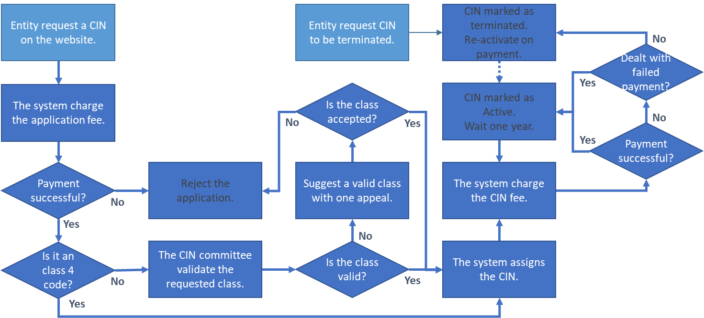
- The application requires: the Entity name, electronic contact details and an optional webpage. This information will be listed with an option not to be listed.
NOTE: All information is confidential and is only used for the application process, other than the displayed Company Name and assigned CIN Number on the webpage.
- All assignees of a XRA CIN are required to provide a report every 12 months on the use of the CIN (see section 7).

Process
- The requester completes the web-request-form.
- Fulfil the application fee. No payment, no process.
- For the 2-, 4-, and 6-digits codes, check the validity of the request. The 8-digit code is valid when the payment is fulfilled.
- If valid,
  - invoice the company the appropriate amount
  - when payment is received, assign an appropriate RAIN CIN,
  - add the CIN and company information to the registry (only after receipt of all moneys owed), and
  - notify the requester with the approved result.
- If not valid,
  - prepare and communicates the denial response, and
  - handle any appeal (this should only be related to the code length).

Request information
- CIN class – while the RAIN Alliance will seek to assign the requested CIN class, the RAIN Alliance cannot guarantee the preferred CIN class will be applicable.
- Preferred number (or Text) if applicable
- Entity name.
- Entity website.
- Entity contact person.
- Entity contact person's electronic contact details.
- Entity general contact information.
- Payment details.
- Reasoning and justification behind application. Sufficient information shall be given to allow the assigning committee to understand the application. This may include details and reasoning for the number of tags to be issued under the CIN, company size etc.
- Projected annual tags per CIN, with a motivation, for the short codes (non-8-digit).
- Acceptance of terms and conditions.
- Request for the Entity information not to be listed. Note, the CIN and its status will be listed.

Response information
When positive:
- Invoice for outstanding amount
- The assigned CIN.
- The CIN class with a motivation if the class is different from the request.
- Payment receipt.
When rejected:
- Motivation for rejection.
- Payment receipt for the admin fees.

Appeal resolution
The requester has one appeal to provide more information in motivation of the request, see 4.3

The RAIN CIN committee
The CIN applications process is implemented with an automated system which requires the RAIN committee to deal with the following:
- Assignment of Classes 1, 2, and 3 by accepting the motivation for the annual potential tags per CIN for the request CIN class.
- The handling of an appeal.
- CIN allocation objection - The RAIN CIN committee will resolve any event where a third-party object to an issued CIN. This may occur where the Entity is operating, say, outside the law. Such objections need to be formally filed, in writing, via the public RAIN contact channels.
The CIN committee shall be appointed by the RAIN Alliance board. The CIN committee shall contain at least 4 members as follows:
- The board member responsible for the IAC operations (or delegated staff person).
- Three RAIN Alliance members – term: two years. (Terms to be staggered)

CIN maintenance

General
The CIN assignment is an automated process. A manual assignment is catered for special cases. The system shall ensure uniqueness of all assignments.
A web-based lookup function CIN-to-Entity and Entity-to-CINs is available on the RAIN Alliance web. It provides for a manual and machine lookup, the latter using JSON. The interface spec is on the manual web page.
The CIN will be checked annually to be valid through an automated payment request, and other means the RAN Alliance deemed to be appropriate.

CIN status
The validity if the CIN shall be validated annually through an automated annual fee request. The CIN has one of the following states:
- Active: Payment up to date with date of last payment.
- Dormant: Payment up to date, Entity indicated CIN not used.
- Reserved: Assigned but not approved for operational use e.g. pending payment
- Terminated: Entity not contactable or indicated termination of use of the CIN, with date of termination.

Rules and obligations

General
An Entity may be assigned one or more CINs. A CIN may only be assigned to one Entity.
The Entity is responsible and accountable for the proper use of its assigned CINs.
The Entity may be a person, a company, an organisation, and a formal proxy of any combination of the aforementioned, or a market vertical. The RAIN Alliance and other representative/influencing organisations, in special cases, may represent an application vertical, e.g., an application vertical may have many small non-associated companies providing a specific service of which the combined tag population have a potential to impact the robust operations of other RAIN applications. Sport timekeeping may be an example of such market vertical.

Agency (RAIN Alliance)
- Establish, operate, and maintain a RAIN CIN committee.
- Review the RAIN company identification code directive under request or within five years after the last review.
- Ensure the uniqueness of the RAIN CINs.
- Consider and assign RAIN CINs.
- Assign and maintain the experimental RAIN CINs, see 3.3.
- Consider, assign, and maintain application vertical RAIN CINs, see 6.1.
- Consider and assign special purpose, as deemed by the RAIN Alliance, RAIN CINs.
- Deal with disputes.
- Ensure the application process is functional.
- Ensure all application requests are responded to with an outcome of approved or denied with comment within 20 business days.
- Ensure the journaling of the requests, responses, and assignment.
- Ensure the active digital lookup of the RAIN CIN is functional.
- Request the annual payment and information update.
- Notify and track the company information confirmation.
- Mark not-confirmed company information as such with the last date of confirmation.
- Mark a non-contactable company as such.

Entity
- Proof that it is a valid legal entity at the time of application and annual renewal.
- Update the Entity and contact information within 30 days after change of such information.
- Confirm annually the company information.
- Respond to the annual survey of use.
- Change a RAIN CIN status. Note a terminated RAIN CIN status may only change when paid up.
- Pay the annual fee using a subscription method.

The RAIN CIN committee
See 4.6 for the RAIN CIN committee functions.
A decision requires a two-third quorum for a simple majority vote. The issue will be escalated to the RAIN board where no decision can be obtained.
RAIN CIN Committee members may provide supplemental information for an application if such “public domain” information is available. The committee member should then recuse themselves from the final vote.

Reporting
All RAIN CIN holders are required to provide an annual report (on the anniversary of the issuing of the RAIN CIN as follows:
- List your RAIN CIN number.
- Provide updated contact details.
- Detail how you meet the Class tag threshold.
- When was the last time you issued a unique number under your RAIN CIN?
- List the applications your RAIN CIN covers.
- How do you ensure uniqueness of the items encoded?

